**Azure Marketplace**

**Azure Marketplace** is an **online store** that offers thousands of **certified, ready-to-use solutions** and **services** from Microsoft and third-party vendors, which can be deployed directly into your Azure environment.

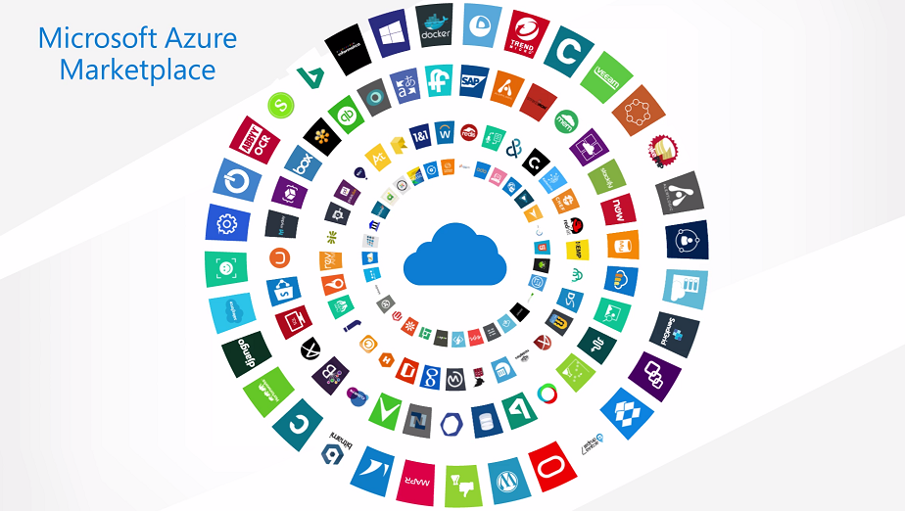

**Features :**

1. **Wide Range of** **Solutions :** Offers VMs, SaaS apps, APIs, containers, templates, and more—from categories like AI, DevOps, networking, and security.
2. **Third-Party** **Integrations :** Easily deploy software from trusted vendors like Red Hat, Cisco, Palo Alto Networks, SAP, and more.
3. **Preconfigured** **Deployments :** Launch complex solutions with pre-built configurations, saving setup time (e.g., WordPress, Ubuntu servers, firewalls).
4. **Billing** **Integration :** Charges are included in your Azure bill—no separate payment process for Marketplace purchases.
5. **Private Offers &** **Plans :** Enterprises can access **custom pricing** and **private agreements** from vendors.